Computer Language Coding Concepts

System Interface of an Object
The main thing you see when showing the system interface of an Object is the Related Items & Related Lists collections.

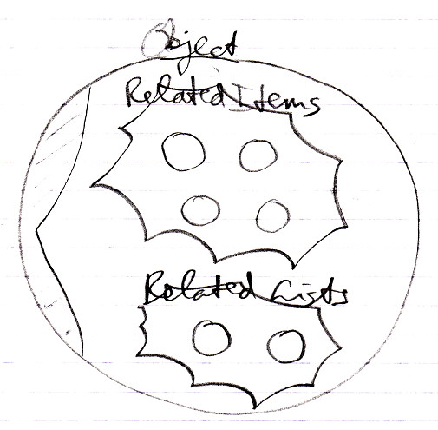

But apart from sub-objects, an object has the following aspects:

- Value
- Class
- Execute
- Clone
- Data

They are controlled through system commands. Those commands will also be visible inside the system interface.

The Value Aspect in the System Interface
The Value aspect is controlled through two commands:

Value Get
Value Set

The Value aspect is represented by a triangle, that wraps together the members to control the Value aspect:

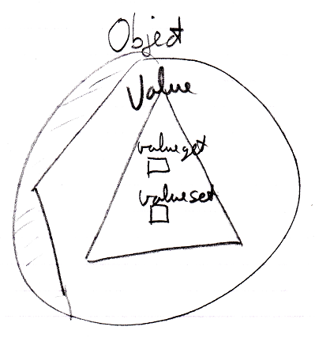

The Object-Class Aspect in the System Interface
The Class aspect has five system commands, but only two of them apply to Objects. The other ones apply to references. The Class aspect of an Object is controlled through the following commands:

Use As Class
Object-Class Get

The commands are placed inside a triangle, that wraps together the members of the Class aspect:

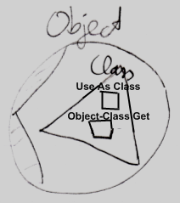

The Execute Aspect in the System Interface
The Execute aspect only applies to executable objects, also called commands. The Execute aspect only has one command:

Execute

The command is placed inside a triangle, that wraps together the members of the Execute aspect:

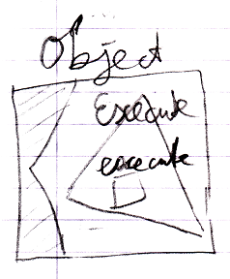

The Clone Aspect in the System Interface
The Clone aspect is controlled through two commands:

Clone Get
Clone Set

Both commands have a Depth parameter to indicate the cloning depth.

The commands are placed inside a triangle, that wraps together the members of the Clone aspect:

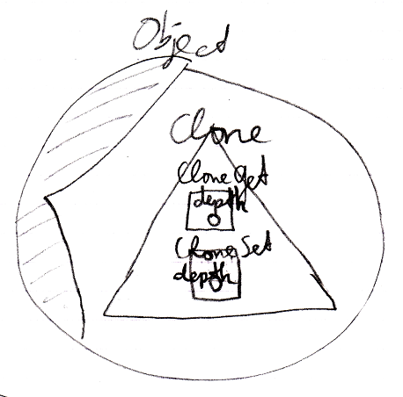

The Data Aspect in the System Interface
The Data aspect is controlled through two system commands:

Data Get
Data Set

The Data Get and Data Set command can not be called; they can only be access-controlled to control read-write access to the object and all the contents of the object.

The commands are placed inside a triangle, that wraps together the members of the Data aspect:

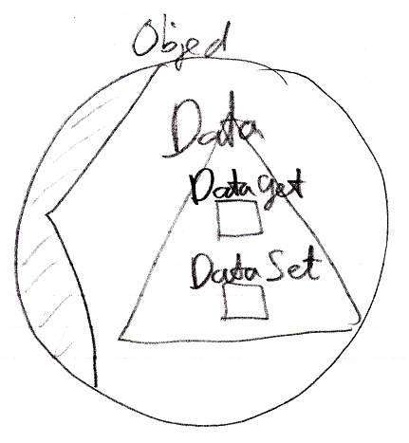

The Full System Interface for Object
The full system interface of an Object looks like this:

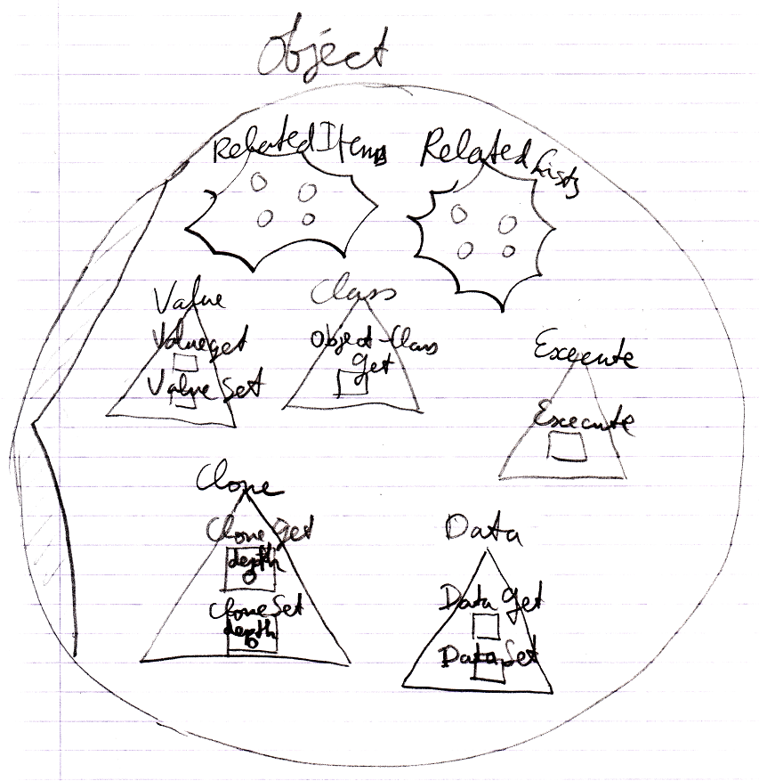

Author & Copyright: Jan-Joost van Zon Date: August 25, 2009 – August 25, 2009 Location: Oosterhout, The Netherlands Status: Finished

